

Republic of the Philippines
BICOL UNIVERSITY
College of Science
Department of Information Technology
Legazpi City, Albay

WEB SYSTEMS AND TECHNOLOGIES FINAL PROJECT
(SY. 2025-2026)

Submitted by

BONEO, Neil Eric B.
GUERRERO, Sean Patrick P.
LASALA, Lenard
RONCESVALLES, Jake P.

Jevah Rea Montas
Instructor, Web Systems & Technologies

- PROJECT OVERVIEW
Original Project Title: SEC-LEO: DOCUMENT Tracking System for Securities and Exchange Commission Legazpi Extension Office

Original Authors/Source: Rica Grace Tango

Module Scope:This module handles the document records management of the Securities and Exchange Commission – Legazpi Extension Office. It allows an authenticated admin to add, view, edit, update the status of, and delete document records, with optional file attachments.

Rationale: This module was chosen because document tracking is a core administrative need for a government extension office. It solves the challenge of organizing, monitoring, and retrieving official documents efficiently. The implementation uses a clean, custom PHP/MySQL stack without any heavy framework, keeping the system lightweight and easy to deploy on a local XAMPP server.

- Technology Stack
• Frontend Framework: HTML, JavaScript
• Styling: CSS (no framework)
• Backend: PHP
• Database: MySQL
• Local Server: XAMPP (Apache + MySQL)

- Database Design
Include an Entity-Relationship Diagram (ERD)
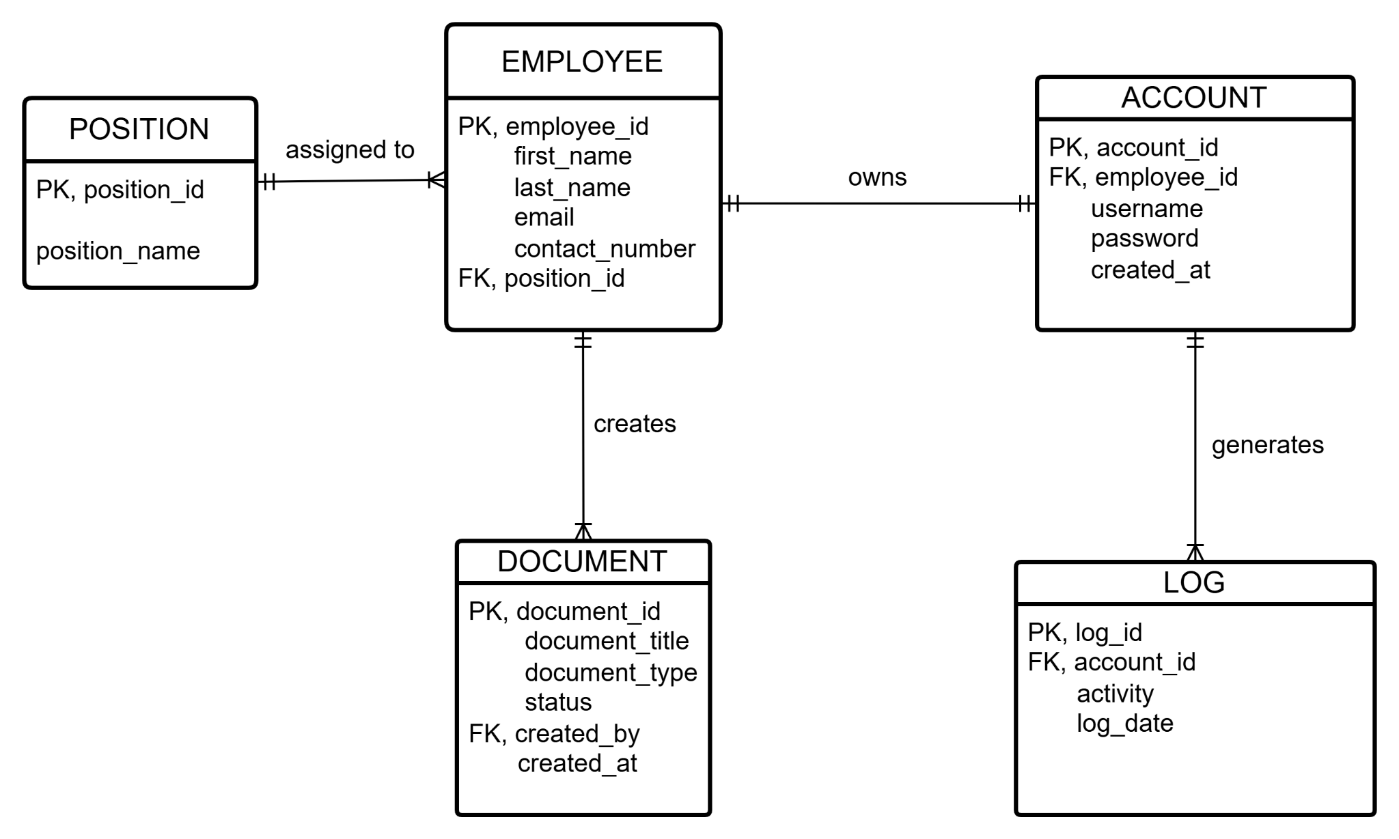

Data types for each field:

Data Dictionary:

POSITION
Field Name | Data Type | Data Format | Field Size | Description | Example
Position_id | Integer | NNNNNNNNNNN | 11 | Unique ID for the Position of Employees (PK) | 123456789
Position_name | VARCHAR |  | 100 | Designated Position name for Employees | Admin

EMPLOYEE
Field Name | Data Type | Data Format | Field Size | Description | Example
Employee_id | Integer | NNNNNNNNNNN | 11 | Unique ID for all Employee (PK) | 12345678967
First_name | VARCHAR |  | 255 | First Name of Employees | Lenard
Last_name | VARCHAR |  | 255 | Last Name of Employees | Lasala
Email | VARCHAR | name@gmail.com | 100 | Email Address of Employees | Ienvrd.on.ig@gmail.com
Position_id | Integer | NNNNNNNNNNN | 11 | Unique ID for the Position of Employees (FK) | 12345678967

ACCOUNT
Field Name | Data Type | Data Format | Field Size | Description | Example
Account_id | Integer | NNNNNNNNNNN | 11 | Unique ID for all Users | 12345678967
Employee_id | Integer | NNNNNNNNNNN | 11 | Unique ID for all Employee (FK) | 12345678967
Username | VARCHAR |  | 100 | Username for Users | Jake
Password | VARCHAR |  | 255 | Password for Users | pogiako123
Created_at | DATE/TIME | 23:59 DD/MM/YY | 50 | Date and time Created | Created at 12:00 03/02/2026

DOCUMENT
Field Name | Data Type | Data Format | Field Size | Description | Example
Document_id | Integer | NNNNNNNNNNN | 11 | Unique ID for the Document | 12345678967
Document_title | VARCHAR |  | 150 | Title of the Document | Annual Financial Report
Document_type | VARCHAR |  | 50 | Type of the Document | PDF
Status | Enum | 'Pending', 'In Process', 'Completed' | 20 | Status of the Document | Completed
Created_by | VARCHAR |  | 50 | Who Created the Document | Created by: Lebron
Created_at | DATE/TIME | 23:59 DD/MM/YY | 50 | Date and time Created | Created at 12:00 03/02/2026

LOG
Field Name | Data Type | Data Format | Field Size | Description | Example
Log_id | Integer | NNNNNNNNNNN | 11 | Unique ID for the logged in Users (PK) | 12345678967
Account_id | Integer | NNNNNNNNNNN | 11 | Unique ID for all Users (FK) | 12345678967
Activity | VARCHAR |  | 255 | Activities of the logged in user | Louis Created a Document
Log_date | DATE/TIME | 23:59 DD/MM/YY | 15 | Date and time  Logged in | 6:00 03/02/2026

- MODULE FEATURES

Create
- Allows the admin to add a new document using a form.
- Required: title, sender, recipient, status
- Optional: description, file upload
- System generates a tracking number automatically
Error Handling:
- Rejects invalid file types
- Prevents empty required fields

Read
- Displays documents stored in the database.
- Shows all documents added
- Includes title, tracking number, status, and date
- Has a search feature (by title)
Error Handling:
- Displays empty state if no documents found

Update
- Allows updating/editing of any document.
- Change document status (Pending, In Process, Completed)
- Edit document details (title, sender, recipient, etc.)
- Replace attached file (optional)
Error Handling:
- Invalid document ID will not update

Delete (Soft Delete)
- Documents are not permanently deleted.
- Instead, they are moved to a Recycle Bin (is_deleted = 1)
- Has confirmation before deleting
Error Handling:
- Prevents deletion if document ID does not exist
- Safely handles missing file (if already deleted)

- Additional Features

Dark Mode
- Switch the system to a dark theme.

Drag and Drop Upload
- Lets users upload files by dragging them into the upload area.

Recycle Bin
- Stores deleted documents before permanent deletion.

Restore
- Brings deleted documents back to the document list.

- Comparison with Original Implementation

Aspect | Original Implementation | Our Implementation
Technology Used | Not clearly defined / basic system | PHP, MySQL, HTML, CSS
Document Handling | Basic CRUD | Added file upload support
Delete Function | Permanent delete | Soft delete (Recycle Bin)
Search Feature | None | Search by document title
User Interface | Basic layout | Improved UI with better styling

- Individual Reflection
Neil Eric Boneo’s Individual Reflection:

1. What was the most difficult part of interpreting the original author's logic?

The most difficult part of interpreting the original author’s logic was understanding how the original database structure and authentication process were designed since some parts of the system were incomplete and needed adjustments based on the updated ERD.

2. What technical challenges did you face during recreation?

The technical challenges I encountered during recreation involved debugging errors in the authentication module and connecting the database properly with the PHP files. Some issues included mismatched database fields, incorrect password verification, and adjusting the login process from email-based authentication to username-based authentication based on the updated system requirements.

3. How would you improve this module further?

If I were to improve this module further, I would improve the security and usability of the system by adding stronger validation, clearer user feedback, and a more organized modular structure. I would also improve the document tracking features by adding real-time notifications, advanced search filters, and better activity logging for more efficient monitoring and management of documents.

Sean Patrick Guerrero’s Individual Reflection:

1. What was the most difficult part of interpreting the original author's logic?

The overall purpose and logic of the system was clear and straightforward, the most difficult was actually executing it and connecting it to the database. It was challenging to translate theoretical database relationships into PHP queries that handle document routing and status updates without data conflicts. It’s difficult not having the original code for reference and just the ERD and a few book pages.

2. What technical challenges did you face during recreation?

The biggest challenges were making the design look nice while still being functional. I struggled most with CSS to get the buttons, spacing, and alignments right. When I change something even a little bit there would be errors and I kept on encountering where when I updated something the button would not work entirely. I also ran into some bugs where parts of the form were showing up twice or the text was overlapping because the design didn't fit. We also have troubles when pushing because of the
merging problem.

3. How would you improve this module further?

I would like to add a user authentication system with role-based access control. Right now, everyone sees the same thing because the dashboard is accessible as a single environment. It would be better if an Admin could see everything, while a regular employee could only see the files they need for their job. A chart would also be good to the overview section to visually track how many documents the office processes each week, month or year.

Lenard Lasala’s Individual Reflection:

1. What was the most difficult part of interpreting the original author's logic?

The original author logic was not that hard to understand because the system had a clear purpose, which was to manage and track documents. The flow of adding, viewing, updating, and deleting documents was easy to follow. The only part that needed more attention was identifying which document details should be included in the form and how they should connect to the database.

2. What technical challenges did you face during recreation?

The technical challenges I faced during recreation were connecting the PHP pages to the database and fixing errors in the document functions.

3. How would you improve this module further?

I would improve this project by deploying it to an actual server instead of running it only on localhost. Since the system is meant for document tracking, it would be more useful if SEC-LEO staff could access it from different computers within the office, instead of using only one XAMPP machine. This would make the project closer to how a real office system works, where records can be accessed, updated, and monitored by authorized users through a shared server.

Jake Roncesvalles’ Individual Reflection:

1. What was the most difficult part of interpreting the original author's logic?

The most difficult part was understanding how different parts of the system connect, especially how documents are created, updated, and displayed dynamically. It also required careful reading of the code to follow how data flows between the database and the interface.

2. What technical challenges did you face during recreation?

Some challenges included handling file uploads, search functionality, and updating documents without errors. Since I have not fully learned PHP yet, I relied heavily on AI to complete these tasks.

3. How would you improve this module further?

The module can be improved by adding pagination for large data, better validation and error messages, user role management, and a more advanced search (e.g., filter by status or date). Enhancing UI/UX and adding notifications would also improve usability.

